Rafting Site Plan – Patricia Niurkiene | WDD 130

Name of Website / Company: Awa Rafting

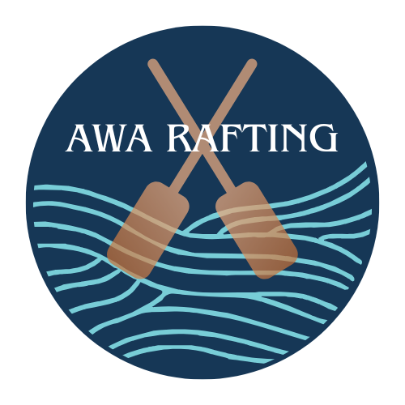Logo:

Colour Palate:

Primary Colour - #163756 (Prussian Blue)

Secondary Colour - #A77E65 (Chamoisee)

Accent Colour 1- #78CDD7 (Tiffiany Blue)

Accent Colour 2 - #FFFFFF (White)

Coolors url: <https://coolors.co/163756-a77e65-78cdd7-ffffff>

Fonts:

Header Font – ITC Benguiat Std

Text Font – Syne